My first Ecommerce project

start: 04/10/20

Set things up

1.make sure you have git & node.js latest version

Just download the msi file. Check version by >>node -v

<https://nodejs.org/en/download/current/>

>>npm i -g npm

<https://www.npmjs.com/>

2. VS code extensions:

* ES7 react /redux/graphQL/ react-native snippits: rcc , rafce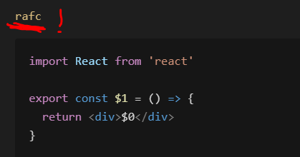
* Bracket pair colorizer
* Auto rename tag -changing opening tac with the closing tag in jsx and html
* Javascript ES6 snippits: clg +enter=> console.log()
* Prettier

FRONT END-Start with create-react-app

>>npx create-react-app frontend (yes! Npx!) :will create it inside frontend folder.

>>cd frontend

>>npm start //will run our frontend (react) web dev server

// ctrl +c will terminate the front end dev server.

Go to package.json=> check out the scripts and dependencies

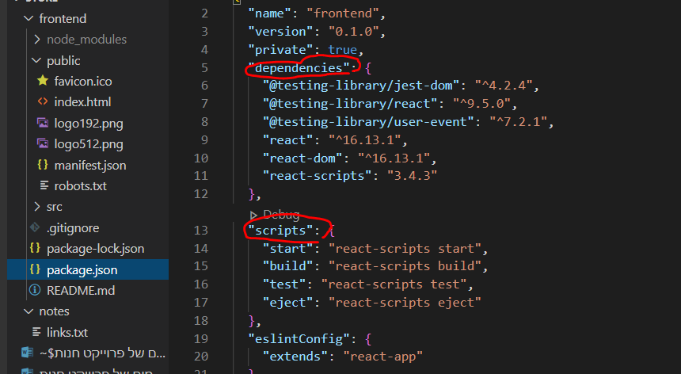

React data flow:

react is a single page application

public-> index.html : the browser initially will read it.

It doesn’t have much in it except for a div with an id attribute “root”, this is the react entry point from:

src-> index.js which contains:

import App from './App';

ReactDOM.render(

  <React.StrictMode>

    <App />

  </React.StrictMode>,

  document.getElementById('root')

);

Src -> app.js is a component containing data that will be rendered to the DOM .

Public-> index.html : clean it a little bit:

<!DOCTYPE html>

<html lang="en">

  <head>

    <meta charset="utf-8" />

    <link

      rel="icon"

      href="%PUBLIC_URL%/Polyverse_logo_ico"

      type="image/x-icon"

    />

    <meta name="viewport" content="width=device-width, initial-scale=1" />

    <meta name="theme-color" content="#000000" />

    <meta

      name="description"

      content="POLYVERSE- makes your music feel different"

    />

    <link rel="apple-touch-icon" href="%PUBLIC_URL%/logo192.png" />

    <link rel="manifest" href="%PUBLIC_URL%/manifest.json" />

    <title>Polyverse Music</title>

  </head>

  <body>

    <noscript>You need to enable JavaScript to run this app.</noscript>

    <div id="root"></div>

  </body>

</html>

will add a description in the tab and a small logo photo.

**Src->**

Files to clean:

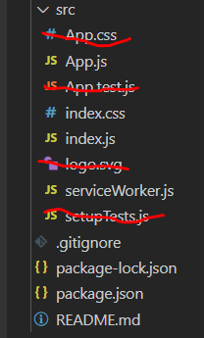

Src-> app.js => lets clean it so the app won’t run what we’ve just deleted:

Did you notice the **JSX** syntax? Same as html with slight different.

Lets clear this code :

 <div className="App">

      <header className="App-header">

        <img src={logo} className="App-logo" alt="logo" />

        <p>

          Edit <code>src/App.js</code> and save to reload.

        </p>

        <a

          className="App-link"

          href="https://reactjs.org"

          target="_blank"

          rel="noopener noreferrer"

        >

          Learn React

        </a>

      </header>

    </div>

Let’s make it an arrow function component:

import React from 'react'

const App = () => {

  return (

    <div>

      <h1>Hi!</h1>

    </div>

  )

}

export default App

src -> index.css =>we will also delete all the content in this file

GIT- version control

Make sure you have the latest version of git.

Terminate the front end dev server by ctrl + c.

Go in windows to the frontend folder: right click ->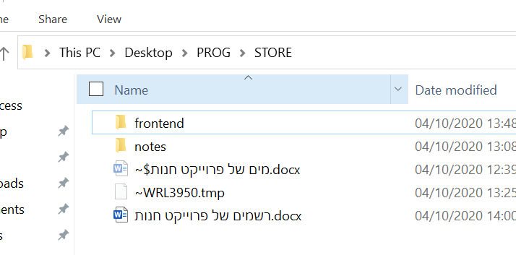

Bit bash here -> git bash cli opens ->

>> ls -a

//you will see all the hidden folders under the frontend folder and specificly the /.git

We want to delete it!

>> rm -rf .git

Now go to the  **.gitignore**  file and move it so it will be under frontend folder!

This file will let to define which folders/ files you don’t want to move to your github repository:

Basically node_modules folder (because you may just download the repo and use

>> npm i to install all dependencies.)

We will make sure you add =>

# dependencies

node_modules -> this one is the frontend node modules.

node_modules/ -> this one is the backend node modules.

# misc

.env

.env ->a file in which we will store some global variables that may contain sensitive information such as pay pal API key , mongoDB URI – we don’t want GitHub users to see.

**Initializing GitHub Rpository:**